Experiment - 4
Operating Systems Lab
Syeda Reeha Quasar
14114802719
6C7
AIM
Write a program to implement CPU scheduling for Round Robin.

EXPERIMENT – 4

Aim:
Write a program to implement CPU scheduling for Round Robin.

Theory:
Round Robin is a CPU scheduling algorithm where each process is assigned a fixed time slot in a cyclic way. It is basically the preemptive version of First come First Serve CPU Scheduling algorithm.
- Round Robin CPU Algorithm generally focuses on Time Sharing technique.
- The period of time for which a process or job is allowed to run in a pre-emptive method is called time quantum.
- Each process or job present in the ready queue is assigned the CPU for that time quantum, if the execution of the process is completed during that time then the process will end else the process will go back to the waiting table and wait for the its next turn to complete the execution.
Characteristics of Round Robin CPU Scheduling Algorithm:
- It is simple, easy to implement, and starvation-free as all processes get fair share of CPU.
- One of the most commonly used technique in CPU scheduling as a core.
- It is preemptive as processes are assigned CPU only for a fixed slice of time at most.
- The disadvantage of it is more overhead of context switching.

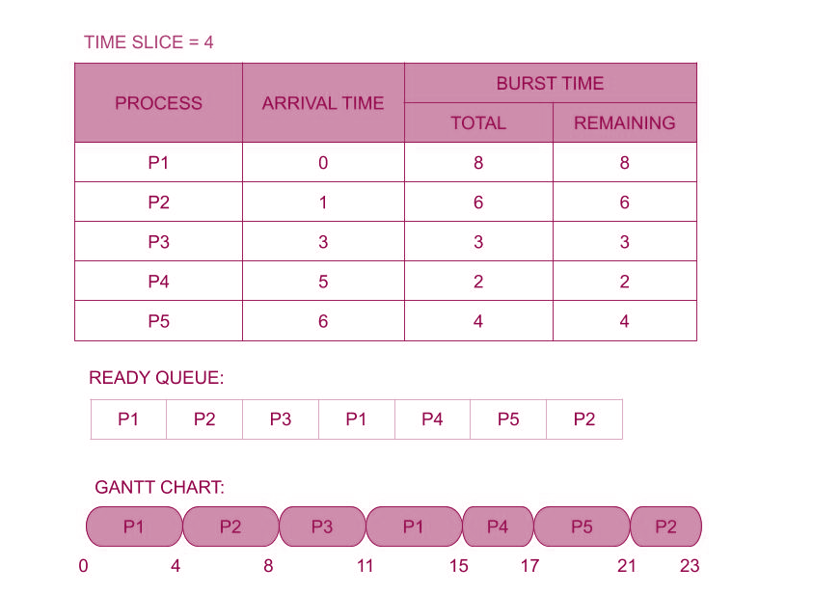

Source Code:

#! /bin/bash

function roundrobin {
#Initializing Bash variables
timeQuantum=0
awt=0
atat=0
temp=0
temp2=0
GanttChart=0
totalwt=0
totaltat=0

declare -a wt
declare -a tat
echo "Enter the Quantum time -- "; #Accepts user input for Quantum Time and Input Validation
read -r timeQuantum

while [[ -z "$timeQuantum" ]] || [[ "$timeQuantum" -le 0 ]]
do
echo "Quantum time cannot be blank or less than 1, please try again."
echo "Enter the Quantum time -- "
read -r timeQuantum
done

echo -e "\n\t\t\t\tGantt Chart"
echo -n "0"
while ((1))
do
for ((i = 1,count=0; i <=number; i++))
do
temp=$timeQuantum

if [ "${rem_bt[i]}" -eq 0 ]
then
((count++))

continue
fi

if [ "${rem_bt[i]}" -gt "$timeQuantum" ]
then
rem_bt[$i]=$((rem_bt[i]-timeQuantum))
GanttChart=$((GanttChart+timeQuantum))
echo -n " -> P[""$i""] <-" "$GanttChart"
else
if [ "${rem_bt[i]}" -ge 0 ]
then
temp=${rem_bt[i]};
GanttChart=$((GanttChart+rem_bt[i]))
echo -n " -> P[""$i""] <-" "$GanttChart"
rem_bt[$i]=0;
fi
fi
temp2=$((temp2+temp))
tat[$i]=$temp2
done
if [ "$number" -eq "$count" ]
then
break
fi

done
echo -e "\n\nProcess\t Burst Time \tWaiting Time\tTurnaround Time"
for ((i = 1; i <= number; i++))
{
wt[i]=$((tat[i]-Btime[i]))
totalwt=$((totalwt+wt[i]))
totaltat=$((totaltat+tat[i]))

echo -e "$i\t\t ${Btime[i]}\t\t ${wt[i]}\t\t\t${tat[i]}"
}
awt=$(echo 'scale=2;' "$totalwt" / "$number" | bc -l)
atat=$(echo 'scale=2;' "$totaltat" / "$number" | bc -l)

echo "Total waiting time =" "$totalwt"
echo "Average waiting time =" "$awt"
echo "Total Turnaround Time =" "$totaltat"
echo "Average Turnaround Time =" "$atat"
}

#Accepts user input for Number of Processes and Input Validation
echo "Enter the number of processes -- "
read -r number
while [[ "$number" -le 1 ]] || [[ -z "$number" ]]
do
echo "Error: Input valid number of processes or Input cannot be blank"
echo "Please try again."
echo "Enter the number of processes -- "
read -r number
done

declare -a Btime
declare -a p
declare -a rem_bt

#Accepts user input for Burst Time and Input Validation
for (( i=1; i<=number; i++ ))
do

echo "Enter Burst Time for Process -- $i"
read -r "Btime[i]"

while [[ "${Btime[i]}" -lt 1 ]] || [[ -z "${Btime[i]}" ]]
do
echo "Error: Input valid burst time for the process or Inputs cannot be blank"
echo "Please try again."
echo "Enter Burst Time for Process -- $i"
read -r "Btime[i]"
done
p[i]=$i #contains process number
rem_bt[i]=${Btime[i]} #remaining process
done

echo -e "CPU burst Time for processes in nano second --" "${Btime[@]}"
echo -e "Process Number for CPU burst time --" "${p[@]}"
echo ""
echo "Calculation for Round Robin for processes entered are as follows: "
roundrobin

Output:

